Introduction

- ACCURATELY HANDLING THE WORD OF TRUTH

  - 2 Timothy 2:15
    - A call to diligence
    - Orthotomeo

- Why Exegetical Fallacies?

- “As dangerous as it is to deny inerrancy, however, it is worse to affirm inerrancy as a doctrinal position and then be careless in the practice of biblical interpretation. All too many who would gladly be martyred in defense of an inerrant Bible make their doctrine of no effect by erroneously interpreting Scripture. Thus, they unwittingly preach and teach error from an inerrant Bible while believing themselves to be defenders of the historic, Christian faith concerning inerrancy.”~ Richard Mayhue

Proof-texting

Isolationism (A text without context is a pretext)

- Isolationism in Action

  - A reason to brush your teeth every day: “My breath is offensive to my wife, and I am loathsome to my own brothers” (Job 19:17).
  - A politically conservative perspective: “A wise man’s heart directs him toward the right, but the foolish man’s heart directs him toward the left” (Ecclesiastes 10:2).
  - The single woman’s favorite Bible verse: “If any man shall come after me, let him …” (Matthew 16:24). But then, of course, if the wrong men come: “I would not have you ignorant brethren.” (Romans 1:13a, KJV)
  - Gatorade in the Bible? “…and Esau said to Jacob, ‘Please let me have a swallow of that red stuff there, for I am famished’” (Genesis 25:30a).
  - When someone gives a long explanation to a simple question: “Is there no limit to windy words? Or what plagues you that you answer?” (Job 16:3).
  - The favorite verse of those who are not morning people: “Whoever blesses his neighbor with a loud voice, rising early in the morning, will be counted as cursing” (Proverbs 27:14 ESV).
  - Every Monday morning on the way to work many people quote Ecclesiastes 2:17: “So I hated life, for the work which had been done under the sun was grievous to me; because everything is futility and striving after wind.”
  - A great welcome mat verse for your front door: “Let your foot rarely be in your neighbor’s house, or he will become weary of you and hate you” (Proverbs 25:17).
  - A plea for singleness: “Yet those who marry will have worldly troubles, and I would [desire to] spare you that” (1 Corinthians 7:28).
  - For conspiracy theorists: “Such things as you are saying have not been done, but you are inventing them in your own mind” (Nehemiah 6:8).
  - For that “one person”: “O that you would be completely silent, and that it would become your wisdom!” (Job 13:5).
  - Why you should be kind to bald people: 2 Kings 2:23–24 – “Then [Elisha] went up from there to Bethel; and as he was going up by the way, young lads came out from the city and mocked him and said to him, ‘Go up, you baldhead; go up, you baldhead!’ When he looked behind him and saw them, he cursed them in the name of the LORD. Then two female bears came out of the woods and tore up forty-two lads of their number.”

- Definition:
  - “Closely associated with proof-texting, yet somewhat different is isolationism. This occurs when we fail to interpret a single Scripture in light of its context. We isolate the Scripture from the immediate literary surroundings.” ~ Richard Mayhue

  - “As bad as this distortion of truth may be, another more serious problem exists in mishandling biblical content. Often, Bible verses are pulled out of context and made to mean what they did not mean to the original audience, usually as a way of making applications to present-day situations.” ~ Les Crawford

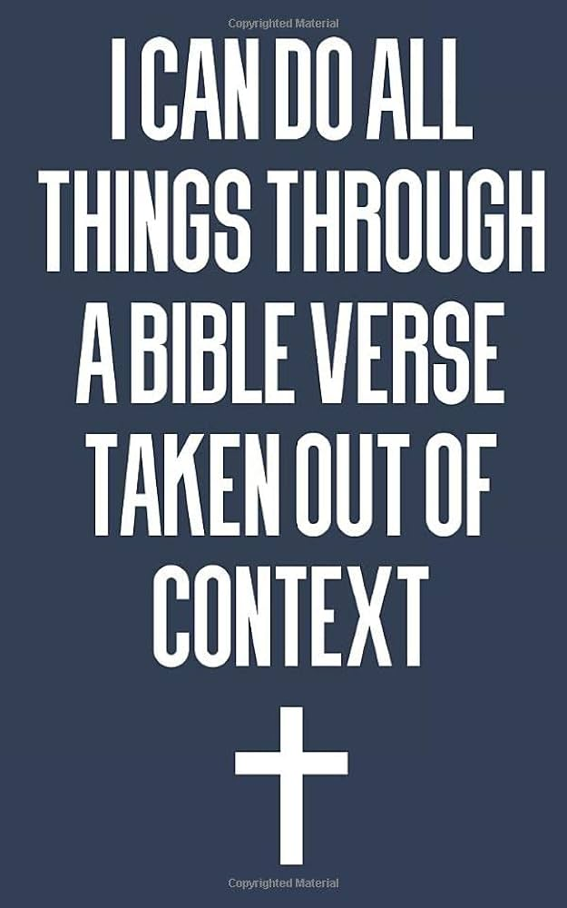

Examples

- Where is the passage on the flow of revelation? NT or OT?
- What is the Literary genre? (Prophecy? Narrative? Epistle? Poetry Wisdom)
- Any historical/ cultural/ geographical significance?
- What is the literary context in the section?
- What is the immediate context? (What comes before and/or after?)
- What is Jesus saying here? How does it tie into what has Jesus been saying?
- Who is doing speaking here? The narrator? A person in the story?
- Based on the information above, what is this passage about?

Is Matthew 18:19-20 a good verse to promote our prayer meetings?

  - Is 2 Chronicles 7:14 a good verse to call America back to repentance?

  - Is Philippians 4:13 a good verse to help us win the BIG GAME!?

  - Is Jeremiah 29:11 a good verse to remind us of God’s plans for us?

  - Is Proverbs 22:6 a promise that your kids will be saved if you do the right things?

  - Does Jeremiah 17:9 say that we can never trust our heart?

  - Does Joshua 1:9 encourage us to be strong and courageous?

  - Does Psalm 51:11 say that if I sin in a big way God can cast me away and the Holy Spirit will be taken away from me?

  - Does James 1:5 say that God will give me wisdom, if I ask in faith?

  - Does Luke 18:27 say that nothing, absolutely nothing is impossible for God?

Why is it dangerous?

  - Eisegesis
  - Does not take into account the theme, context, and purpose of the book.
  - Does not respect authorial intent.
  - Does not consider progressive revelation.

Richard Mayhue, “How to study the Bible,” (Great Britain: Christian Focus ,2001), 85.
Les Crawford, “The Dangers of Taking Bible Verses Out of Context” (Friends of Israel: https://www.foi.org/2020/10/02/the-dangers-of-taking-bible-verses-out-of-context/) Accessed 4/17/2024.

